Cryptography and Network Security Lab

Assignment 11  
Implementation and Understanding of Diffie-Hellman Key Exchange Algorithm

2019BTECS00058  
Devang K

Batch: B2

Title: Implementation and Understanding of Diffie-Hellman Key Exchange Algorithm

Aim: To Study, Implement and Demonstrate the Diffie-Hellman Key Exchange Algorithm

Theory:

Diffie–Hellman key exchange is a mathematical method of securely exchanging cryptographic keys over a public channel and was one of the first public-key protocols as conceived by Ralph Merkle and named after Whitfield Diffie and Martin Hellman. DH is one of the earliest practical examples of public key exchange implemented within the field of cryptography. Published in 1976 by Diffie and Hellman, this is the earliest publicly known work that proposed the idea of a private key and a corresponding public key.

Traditionally, secure encrypted communication between two parties required that they first exchange keys by some secure physical means, such as paper key lists transported by a trusted courier. The Diffie–Hellman key exchange method allows two parties that have no prior knowledge of each other to jointly establish a shared secret key over an insecure channel. This key can then be used to encrypt subsequent communications using a symmetric-key cipher.

Diffie–Hellman is used to secure a variety of Internet services. However, research published in October 2015 suggests that the parameters in use for many DH Internet applications at that time are not strong enough to prevent compromise by very well-funded attackers, such as the security services of some countries.

We look at an illustration:

Diffie–Hellman key exchange establishes a shared secret between two parties that can be used for secret communication for exchanging data over a public network. An analogy illustrates the concept of public key exchange by using colors instead of very large numbers:

The process begins by having the two parties, Alice and Bob, publicly agree on an arbitrary starting color that does not need to be kept secret. In this example, the color is yellow. Each person also selects a secret color that they keep to themselves – in this case, red and cyan. The crucial part of the process is that Alice and Bob each mix their own secret color together with their mutually shared color, resulting in orange-tan and light-blue mixtures respectively, and then publicly exchange the two mixed colors. Finally, each of them mixes the color they received from the partner with their own private color. The result is a final color mixture (yellow-brown in this case) that is identical to their partner’s final color mixture.

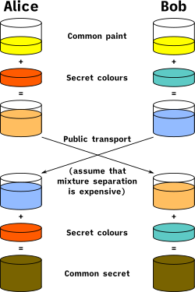

We look at Cryptographic Explanation:

The simplest and the original implementation of the protocol uses the multiplicative group of integers modulo p, where p is prime, and g is a primitive root modulo p. These two values are chosen in this way to ensure that the resulting shared secret can take on any value from 1 to p–1. Here is an example of the protocol, with non-secret values in blue, and secret values in red.

1. Alice and Bob publicly agree to use a modulus p = 23 and base g = 5 (which is a primitive root modulo 23).
2. Alice chooses a secret integer a = 4, then sends Bob A = ga mod p
   1. A = 54 mod 23 = 4 (in this example both A and a have the same value 4, but this is usually not the case)
3. Bob chooses a secret integer b = 3, then sends Alice B = gb mod p
   1. B = 53 mod 23 = 10
4. Alice computes s = Ba mod p
   1. s = 104 mod 23 = 18
5. Bob computes s = Ab mod p
   1. s = 43 mod 23 = 18
6. Alice and Bob now share a secret (the number 18).

Both Alice and Bob have arrived at the same values because under mod p,

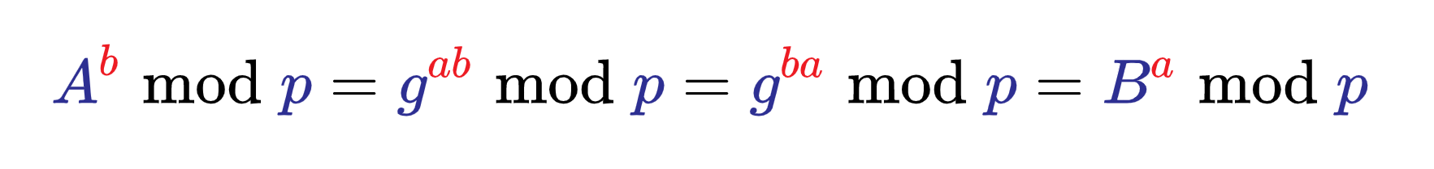

More specifically,

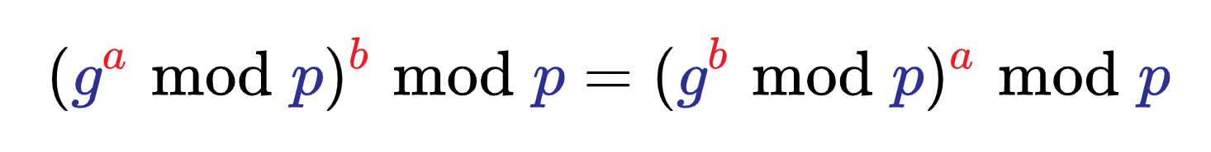

Only a and b are kept secret. All the other values – p, g, ga mod p, and gb mod p – are sent in the clear. The strength of the scheme comes from the fact that gab mod p = gba mod p take extremely long times to compute by any known algorithm just from the knowledge of p, g, ga mod p, and gb mod p. Once Alice and Bob compute the shared secret they can use it as an encryption key, known only to them, for sending messages across the same open communications channel.

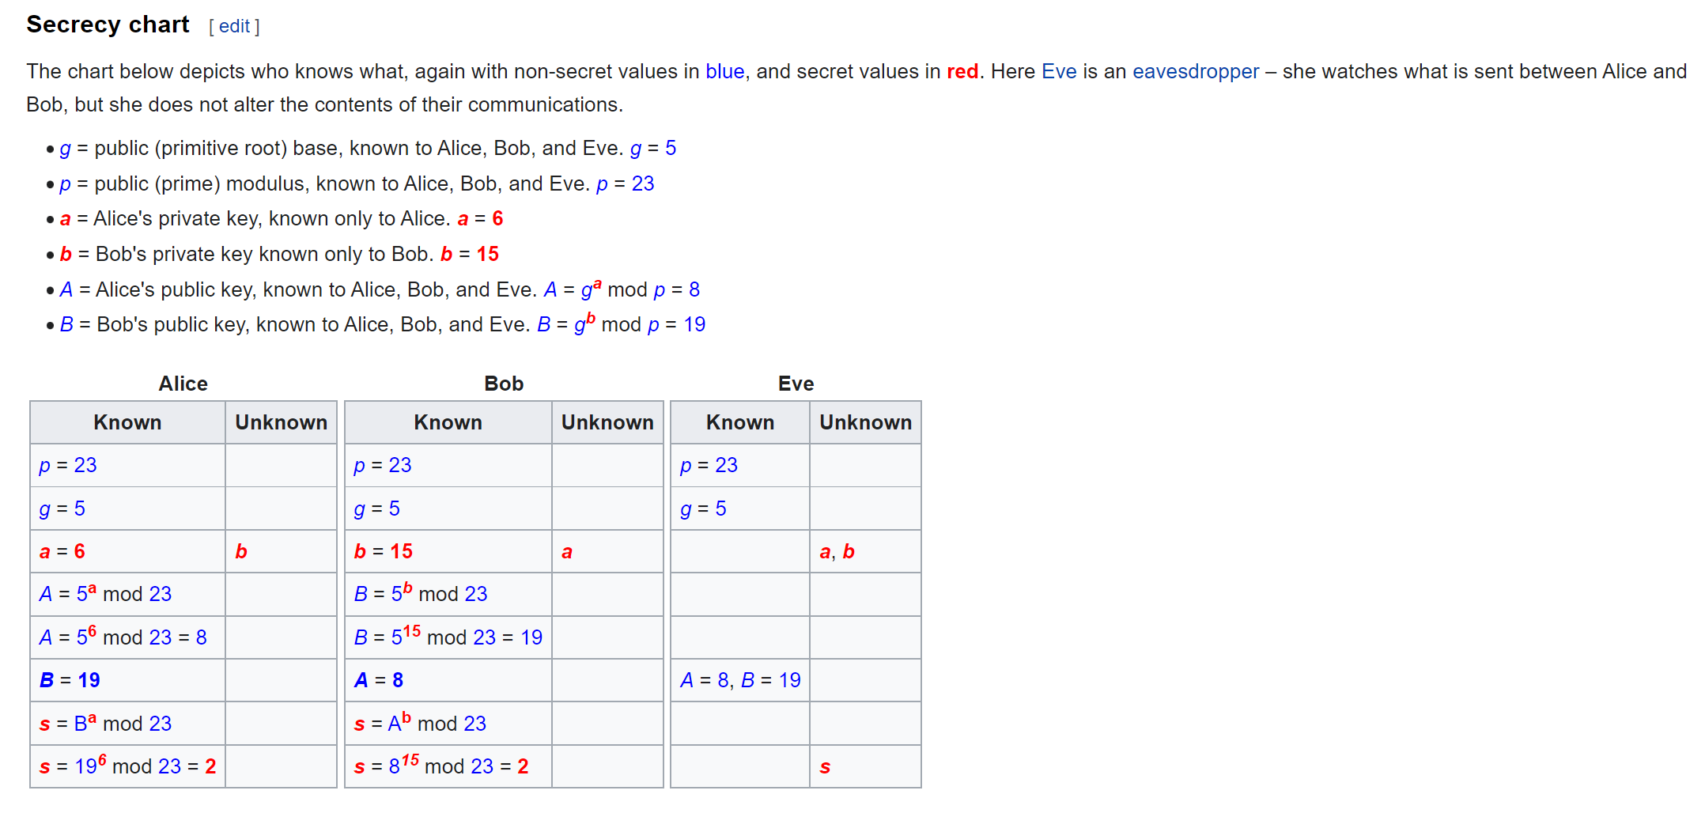

Let’s now look at the program implementation.

Code:

We have implemented the program in React + Node using Socket.io

There’s a server-side Node.js server which acts as a relay for the data passing. In node, we write the script to open the portal for the socket, then broadcast the incoming data:

*const* express = require('express');

*const* app = express();

*const* cors = require("cors");

*const* http = require('http').createServer(app);

*const* PORT = 8080;

*const* io = require('socket.io')(http,{cors: {origin: "*"}});

app.use(cors());

app.use(require('express').json());

*let* p = 0;

*let* g = 0;

*let* sharedKeyOfAlice = 0

*let* sharedKeyOfBob = 0;

io.on("connection", (socket) *=>* {

  console.log("Someone joined!");

  socket.on("hello", (message)*=>*{

    console.log(message)

  });

  socket.on("publicKeyValues", (keys)*=>*{

    p = keys['p'];

    g = keys['g'];

    console.log(p)

    console.log(g)

    socket.broadcast.emit("publicKeyValues", keys);

  });

  socket.on("privKeyValueAlice", (value)*=>*{

    sharedKeyOfAlice = value

    socket.broadcast.emit("privKeyValueAlice", sharedKeyOfAlice);

  });

  socket.on("privKeyValueBob", (value)*=>*{

    sharedKeyOfBob = value

    socket.broadcast.emit("privKeyValueBob", sharedKeyOfBob);

  });

});

io.listen(PORT);

In the React side, we use socket-io-client and build 3 pages for the 3 users – Alice, Bob and Eve.

For the project, we assume that Alice enters the Public Keys (P and G). Then both Alice and Bob would create the private keys and receive their final key. Eve, meanwhile is able to eavesdrop on the data shared by Alice and Bob.

Alice:

*import* React, {useState, useEffect} *from* 'react'

*import* socketClient  *from* "socket.io-client";

*const* SERVER = "http://localhost:8080";

*function* gcd(x, y) {

*if* ((typeof x !== 'number') || (typeof y !== 'number'))

*return* false;

    x = Math.abs(x);

    y = Math.abs(y);

*while*(y) {

*var* t = y;

      y = x % y;

      x = t;

    }

*return* x;

}

*const* checkIfPrimitiveRoot = (p, g) *=>* {

*if*(g<0 || gcd(p,g)!=1 || g>=p){

        alert("g<0 || gcd(p,g)!=1 || g>=p")

*return* false;

    }

*let* solutionsList = [];

*for*(*let* i=1; i<p; i++){

*let* value = Math.pow(g, i);

        value %= p

*if*(solutionsList.includes(value)){

            alert(solutionsList)

            alert(value)

*return* false;

        }

        solutionsList.push(value);

    }

*return* true;

}

*export* *default* *function* Alice() {

*var* socket = socketClient (SERVER, {

        rejectUnauthorized: false *// WARN: please do not do this in production*

    });

    socket.on("connect", () *=>* {

        console.log(socket.id); *// x8WIv7-mJelg7on_ALbx*

        socket.emit('hello', "Hello from Alice!")

    });

*const* [arePublicKeysDeclared, setArePublicKeysDeclared] = useState(false);

*const* [areKeysExchanged, setAreKeysExchanged] = useState(false);

*const* [hasSharedKey, setHasSharedKey] = useState(false);

*const* [hasIncomingKeyReceived, setHasIncomingKeyReceived] = useState(false)

*const* [p, setP] = useState(0);

*const* [g, setG] = useState(0);

*const* [privKey, setPrivKey] = useState(0);

*const* [keyToExchange, setKeyToExchange] = useState(0);

*const* [incomingSharedKey, setIncomingSharedKey] = useState(0);

*const* [finalKey, setFinalKey] = useState(-1)

*const* publicKeysSubmitHandler = (e) *=>* {

        e.preventDefault();

*if*(!checkIfPrimitiveRoot(p, g)){

            alert('Invalid Value of Primitive Root.');

*return*;

        }

        socket.emit("publicKeyValues", {

            p, g

        });

        setArePublicKeysDeclared(true);

    }

*const* keysExchangeSubmitHandler = (e) *=>* {

        e.preventDefault();

*let* theValueToExchange = Math.pow(g, privKey);

        theValueToExchange %= p;

        setKeyToExchange(theValueToExchange)

        socket.emit("privKeyValueAlice", theValueToExchange);

        setAreKeysExchanged(true);

    }

    socket.on("privKeyValueBob", (value)*=>*{

        setIncomingSharedKey(value);

        setHasSharedKey(true);

        setHasIncomingKeyReceived(true)

    });

*const* computeFinalKey = () *=>* {

*let* finalKeyValue = Math.pow(incomingSharedKey, privKey);

        finalKeyValue %= p;

        setFinalKey(finalKeyValue)

    }

*if*(finalKey === -1){

*if*(areKeysExchanged&&hasIncomingKeyReceived){

            computeFinalKey()

        }

    }

*return* (

    <div *className*='container container-fluid'>

        <h2 *style*={{textAlign: 'center', marginBottom: '1rem'}}>Alice 👧</h2>

        {!arePublicKeysDeclared ? <></> : <div *className*='container container-fluid'>

          <h6>Public Keys:</h6>

          <h6>P: {p}</h6>

          <h6>G: {g}</h6>

          </div>}

        {!arePublicKeysDeclared ? <form *className*='PandG' *onSubmit*={publicKeysSubmitHandler} >

            <div *className*="form-group">

                <label *htmlFor*="p">Enter Public Key P</label>

                <input *onChange*={(e)*=>*setP(parseInt(e.target.value))} *type*="number" *className*="form-control" *id*="p" *placeholder*="P" *required* />

            </div>

            <div *className*="form-group">

                <label *htmlFor*="g">Enter Public Key G</label>

                <input *onChange*={(e)*=>*setG(parseInt(e.target.value))} *type*="number" *className*="form-control" *id*="g" *placeholder*="G - Primitive Root of P" *required* />

            </div>

            <button *style*={{margin: '1rem auto'}} *type*="submit" *class*="btn btn-primary">Submit</button>

        </form> : <></>}

        {arePublicKeysDeclared && !areKeysExchanged ? <>

        <div>

          <h6>Selection of Private Key and Exchange</h6>

          <form *className*='privKey' *onSubmit*={keysExchangeSubmitHandler} >

            <div *className*="form-group">

              <label *htmlFor*="privKey">Enter Private Key</label>

              <input *onChange*={(e)*=>*setPrivKey(parseInt(e.target.value))} *type*="number" *className*="form-control" *id*="privKey" *placeholder*="Private Key" *required* />

            </div>

            <button *style*={{margin: '1rem auto'}} *type*="submit" *class*="btn btn-primary">Submit</button>

        </form>

        </div>

        </> : <></>}

        {areKeysExchanged && !hasSharedKey ? <>

        <div>

          <h6>Key Shared on Public Channel - {keyToExchange}</h6>

          <h6>Waiting for Key to be shared from Bob...</h6>

        </div>

        </> : <></>}

        {areKeysExchanged&&hasIncomingKeyReceived ? <>

        <div *className*='container container-fluid'>

            <h6>Key Shared on Public Channel - {keyToExchange}</h6>

            <h6>Incoming Key - {incomingSharedKey}</h6>

        </div>

        <div *className*='container container-fluid'>

            <h6>We get final common key as: {finalKey}</h6>

        </div>

        </> : <></>}

    </div>

  )

}

Bob:

*import* React, {useState, useEffect} *from* 'react'

*import* socketClient  *from* "socket.io-client";

*const* SERVER = "http://localhost:8080";

*export* *default* *function* Bob() {

*var* socket = socketClient (SERVER, {

    rejectUnauthorized: false *// WARN: please do not do this in production*

  });

  socket.on("connect", () *=>* {

      console.log(socket.id); *// x8WIv7-mJelg7on_ALbx*

      socket.emit('hello', "Hello from Bob!")

  });

*const* [arePublicKeysDeclared, setArePublicKeysDeclared] = useState(false);

*const* [areKeysExchanged, setAreKeysExchanged] = useState(false);

*const* [hasSharedKey, setHasSharedKey] = useState(false)

*const* [hasIncomingKeyReceived, setHasIncomingKeyReceived] = useState(false)

*const* [p, setP] = useState(0);

*const* [g, setG] = useState(0);

*const* [privKey, setPrivKey] = useState(0);

*const* [keyToExchange, setKeyToExchange] = useState(0);

*const* [incomingSharedKey, setIncomingSharedKey] = useState(0)

*const* [finalKey, setFinalKey] = useState(-1)

  socket.on("publicKeyValues", (keys)*=>*{

    setP(keys['p'])

    setG(keys['g'])

    setArePublicKeysDeclared(true);

  });

*const* keysExchangeSubmitHandler = (e) *=>* {

    e.preventDefault();

*let* theValueToExchange = Math.pow(g, privKey);

    console.log(theValueToExchange);

    console.log("Aaaaaaa")

    theValueToExchange %= p;

    setKeyToExchange(theValueToExchange)

    socket.emit("privKeyValueBob", theValueToExchange);

    setAreKeysExchanged(true);

  }

  socket.on("privKeyValueAlice", (value)*=>*{

    setIncomingSharedKey(value);

    setHasSharedKey(true);

    setHasIncomingKeyReceived(true)

  })

*const* computeFinalKey = () *=>* {

*let* finalKeyValue = Math.pow(incomingSharedKey, privKey);

    finalKeyValue %= p;

    setFinalKey(finalKeyValue)

  }

*if*(finalKey === -1){

*if*(areKeysExchanged&&hasIncomingKeyReceived){

        computeFinalKey()

    }

  }

*return* (

    <div *className*='container container-fluid'>

        <h2 *style*={{textAlign: 'center', marginBottom: '1rem'}}>Bob 👦</h2>

        {!arePublicKeysDeclared ? <p>Waiting for declaration of Public Keys...</p> : <div *className*='container container-fluid'>

          <h6>Public Keys:</h6>

          <h6>P: {p}</h6>

          <h6>G: {g}</h6>

          </div>}

        {arePublicKeysDeclared && !areKeysExchanged ? <>

        <div>

          <h6>Selection of Private Key and Exchange</h6>

          <form *className*='privKey' *onSubmit*={keysExchangeSubmitHandler} >

            <div *className*="form-group">

              <label *htmlFor*="privKey">Enter Private Key</label>

              <input *onChange*={(e)*=>*setPrivKey(parseInt(e.target.value))} *type*="number" *className*="form-control" *id*="privKey" *placeholder*="Private Key" *required* />

            </div>

            <button *style*={{margin: '1rem auto'}} *type*="submit" *class*="btn btn-primary">Submit</button>

        </form>

        </div>

        </> : <></>}

        {areKeysExchanged && !hasSharedKey ? <>

        <div>

          <h6>Key Shared on Public Channel - {keyToExchange}</h6>

          <h6>Waiting for Key to be shared from Alice...</h6>

        </div>

        </> : <></>}

        {areKeysExchanged&&hasIncomingKeyReceived ? <>

        <div *className*='container container-fluid'>

            <h6>Key Shared on Public Channel - {keyToExchange}</h6>

            <h6>Incoming Key - {incomingSharedKey}</h6>

        </div>

        <div *className*='container container-fluid'>

            <h6>We get final common key as: {finalKey}</h6>

        </div>

        </> : <></>}

    </div>

  )

}

Eve:

*import* React, {useState, useEffect} *from* 'react'

*import* socketClient  *from* "socket.io-client";

*const* SERVER = "http://localhost:8080";

*export* *default* *function* Eve() {

*var* socket = socketClient (SERVER, {

    rejectUnauthorized: false *// WARN: please do not do this in production*

  });

*const* [arePublicKeysReceived, setArePublicKeysReceived] = useState(false);

*const* [p, setP] = useState(0)

*const* [g, setG] = useState(0)

*const* [isKeySharedByAlice, setIsKeySharedByAlice] = useState(false)

*const* [keySharedByAlice, setKeySharedByAlice] = useState(0)

*const* [isKeySharedByBob, setIsKeySharedByBob] = useState(false)

*const* [keySharedByBob, setKeySharedByBob] = useState(0)

  socket.on("connect", () *=>* {

      console.log(socket.id); *// x8WIv7-mJelg7on_ALbx*

      socket.emit('hello', "Hello from Eve!")

  });

  socket.on("publicKeyValues", (keys)*=>*{

    setP(keys['p']);

    setG(keys['g']);

    setArePublicKeysReceived(true);

  });

  socket.on("privKeyValueAlice", (value)*=>*{

    setKeySharedByAlice(value);

    setIsKeySharedByAlice(true);

  });

  socket.on("privKeyValueBob", (value)*=>*{

    setKeySharedByBob(value);

    setIsKeySharedByBob(true);

  });

*return* (

    <div *className*='container container-fluid'>

        <h2 *style*={{textAlign: 'center', marginBottom: '2rem'}}>Eve 😈</h2>

        <div *className*='container container-fluid'>

          <h6>Public Key P: {arePublicKeysReceived ? p : 'Waiting for it...'}</h6>

          <h6>Public Key G: {arePublicKeysReceived ? g : 'Waiting for it...'}</h6>

          <h6>Key Shared By Alice: {isKeySharedByAlice ? keySharedByAlice : 'Waiting for it...'}</h6>

          <h6>Key Shared By Bob: {isKeySharedByBob ? keySharedByBob : 'Waiting for it...'}</h6>

        </div>

    </div>

  )

}

We now illustrate with examples:

Say we wish to demonstrate the example above.

P – 23

G – 5

a – 6 (Private key chosen by Alice)

b – 15 (Private key chosen by Bob)

Now, we start with Alice:

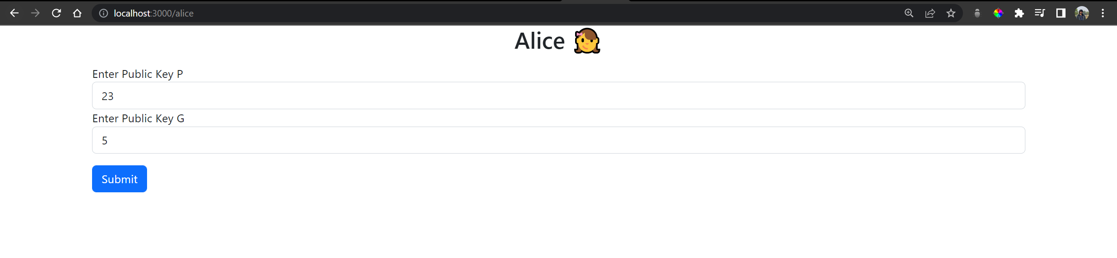

Meanwhile, Bob and Eve are idle and waiting.



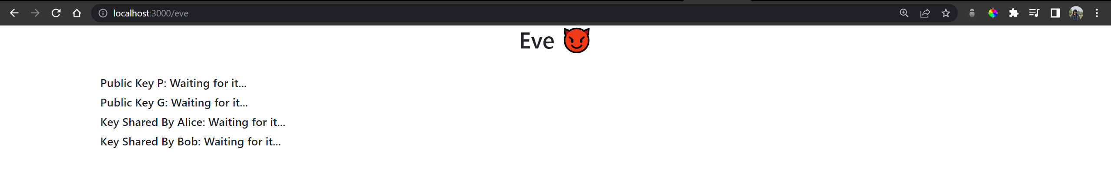

After Alice submits the key:

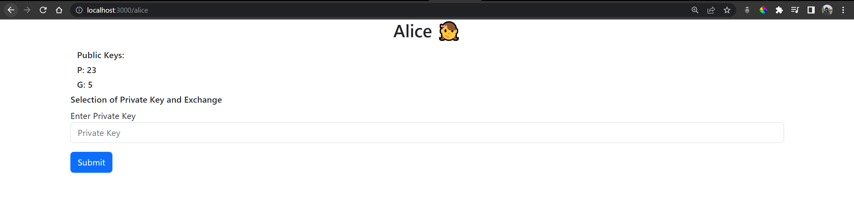

Same with Bob:

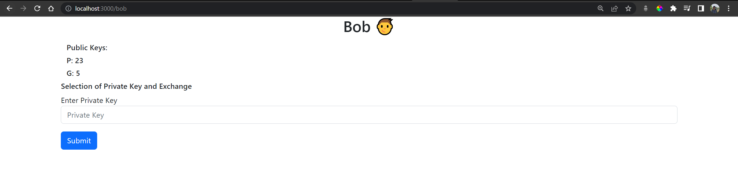

And with Eve:

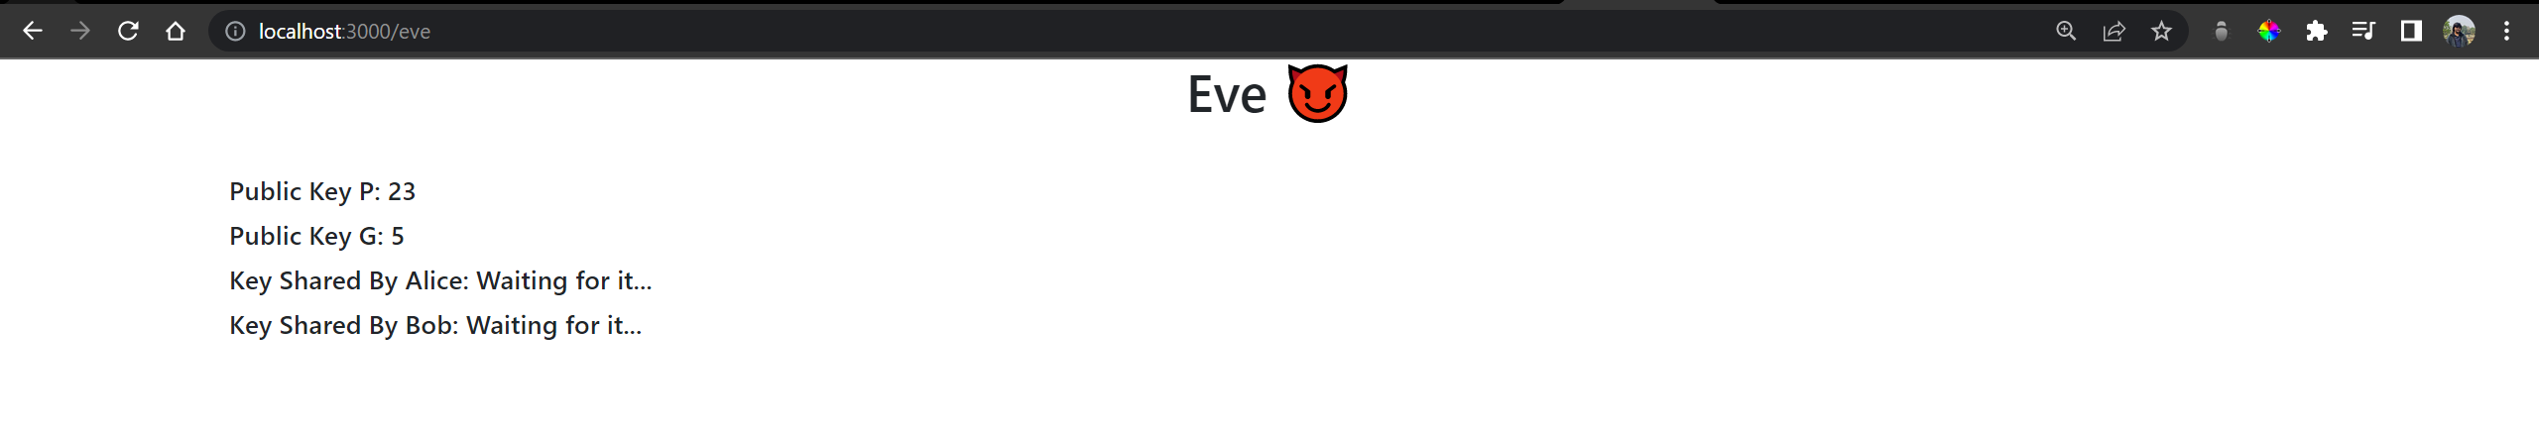

When Alice and Bob enter 6 and 15 respectively:

Alice:

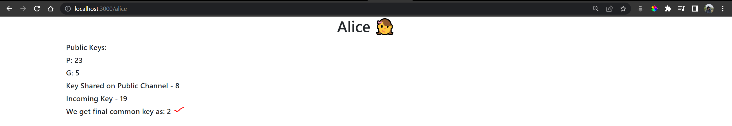

Bob:

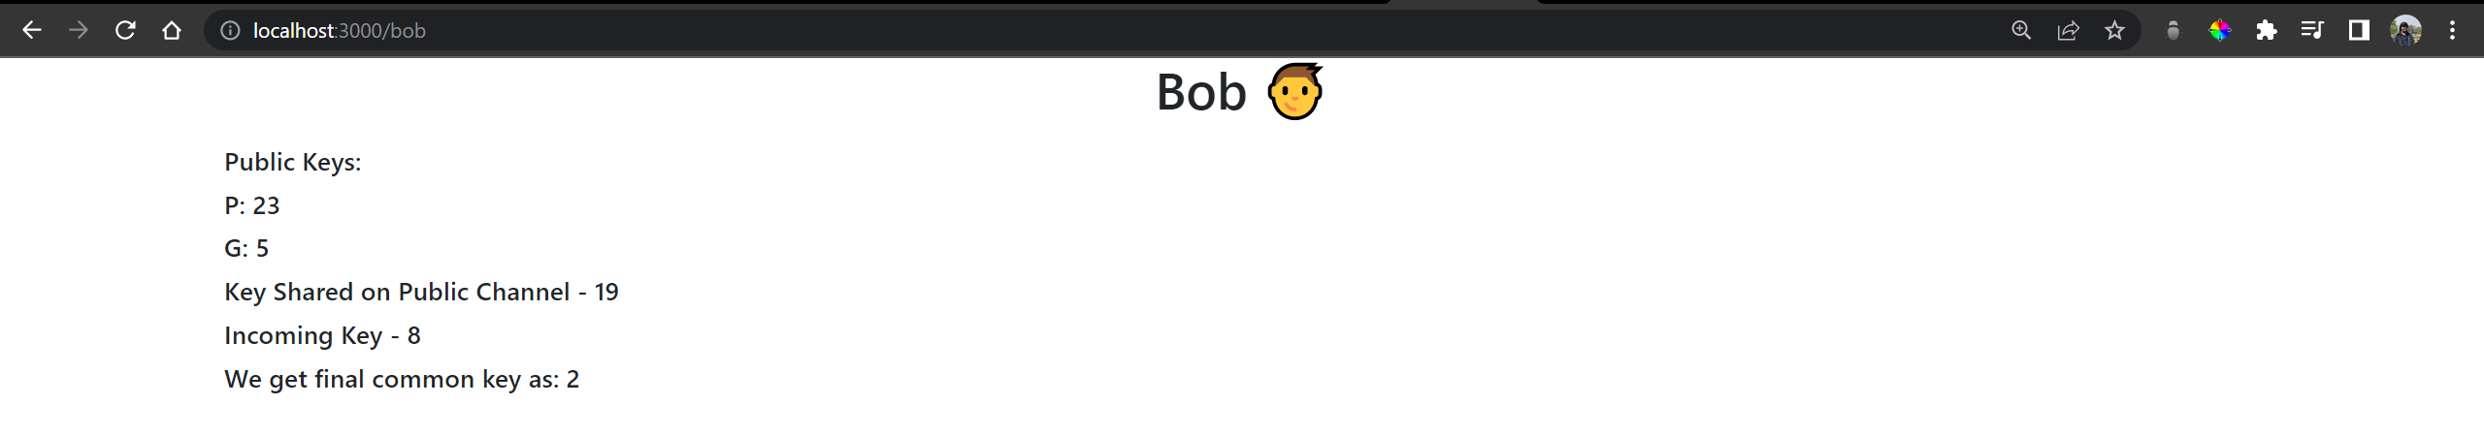

Eve:

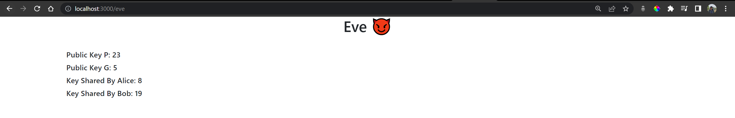

Thus, we see that Alice and Bob compute the required common final key on their end, meanwhile Eve does not know the a and b to do so.

Discrete logarithm would be used to hack Diffie Hellman. Therefore, for very large numbers, this algorithm would be secure.

Conclusion:

Thus, the Diffie-Hellman Key Exchange algorithm was studied and demonstrated with the code.